Generics Points

1. Create two folders as backend and frontend
2. Inside backend folder create Eureka Server project with two starter web starter and eureka server

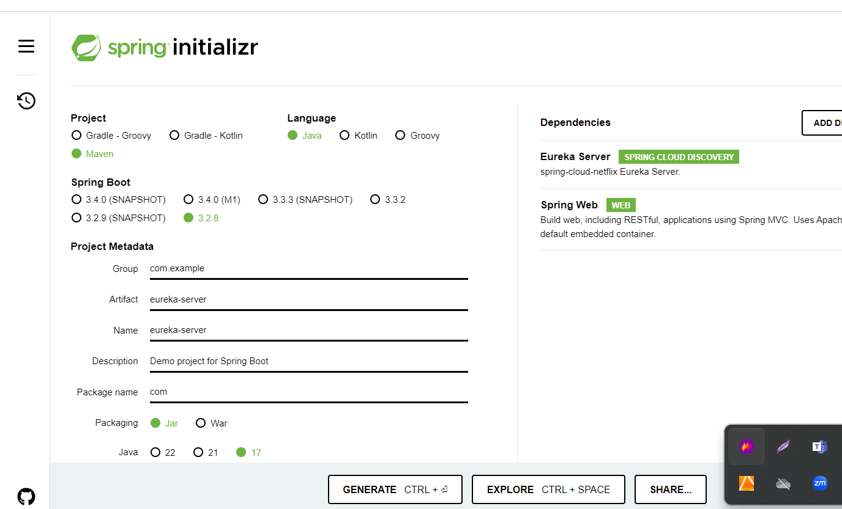

1. Create micro-service-app

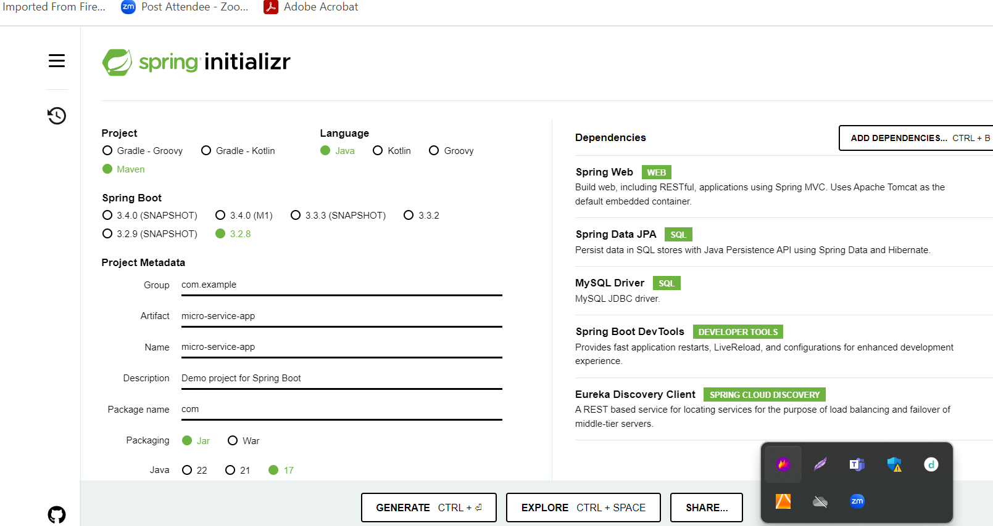

1. Create more than on rest api depending upon the application requirements.

Here we create simple rest api to retrieve student information.

1. Now we will create front-end app using angular to access these rest api.

ng new front-end-app

routing 🡪 yes

styling 🡪 css

ng g c student

ng g class student

ng g s student

**below link contains capstone project demo app**

<https://github.com/Kaleakash/capstone_project_test.git>